***Robin Munro:***

***Memories and Tributes***

*Version date: June 22, 2021*

***Pao-lien Huang 黃寳蓮***

To my dearest husband Robin James Munro:

O Rose thou art sick.

The invisible worm,

That flies in the night

In the howling storm:

Has found out thy bed

Of crimson joy:

And his dark secret love

Does thy life destroy.

—The Sick Rose, by William Blake

It is unexpected yet inevitable, or you could say it's destiny if you believe in fate.

When he was sick at the end of March, Robin, my dearest husband, read this poem to me, with tears in his eyes. He sensed that his time was up. Cancer didn't take his life. Since he was diagnosed with the last stage of Carcinoid cancer ten years ago, he had lived with the disease healthily. In Taiwan he had enjoyed music, reading, cycling, fresh mountain air, beach, good food, hearty friendship .... Life is beautiful.

Then unexpectedly, a little tiny abscess with unidentified and vicious germs in his liver eventually turned into septicemia.

On his last day under unconscious condition, he waited, waited, and waited until the right moment.

Then his heart stopped beating.

It was May 19, 5:20 p.m. I was then told that 5:20 in Chinese is pronounced wo-ai-ni (I LOVE YOU).

He left with peace and grace, as he said, he had no regrets in life.



***Sandra Moscardini***

Robin was my little brother and I loved him.

We spent only a small part of our adult lives on the same continent but we remained always close and great friends. The memories of time we spent geographically close are very clear and precious, especially during the time he worked for Amnesty and was based in London. I was pregnant with my second son and we spent many happy hours swinging the 2-year-old, Joe, between us in the park while I waited for the birth of Max, my second baby. Shortly before Max was born in May 1989, Robin went off to China and the rest is history.

I have so many great memories of him playing the guitar beautifully and us singing together, so many rambling talks by Skype between Italy and Taiwan these last ten years, where we discussed anything and everything. My great regret is not having been able to see him again before he died but I am comforted knowing that Pao-lien, who he adored, was with him to the end.

He and Pao-lien were due to visit us here last summer but of course Covid put a stop to that.

For most people Robin was a courageous champion of human rights in China, and to me of course he was that, but also just my little brother. Infuriating at times but an exceptional human being and a wonderful brother who I will miss terribly.

Rest in peace dear Robin, and wherever you are now I hope there is good music.



***Anonymous (Chinese labor activist)***

*工友之友*

中国工人权益的维护者和推动者，其实有很多，诸如官方的工会、劳动部门和各行业协会等。民间社会的力量也不可或缺，民间社会力量总能扮演一种积极的角色，或隐或现一直是现象版的存在。比如身在香港的美国人罗宾，就是这样的一位，他低调、睿智，极具大局观。

2005年，我应邀参加一家香港社会组织主办的世贸多边谈判论坛，在会议上经朋友介绍认识了Robin，一个工作生活在香港的美国人。

经过了短暂的一个多小时的交流，Robin知识广度与深度、观察社会维度和精度都是超出我的想象。当时，中国受加入世贸的影响，劳动条款逐渐被商业行为所吸纳，受到了世界广泛的关注，维权个案成井喷状。Robin自问到，诸多的个案发生，正是我们工人组织的弱化，民间社会组织如果只考虑替工人维权显然是不够的，怎么能把工人组织起来，通过赋能，提升其谈判能力。

Robin还讲到，社会经济快速发展，社会组织的出现正是社会需求的体现，在维护劳工权益的大环境下，如何同工会合作，扮演更多更好的角色也是我们社会组织主动要去思考的。

确切地说，Robin的分析给我上了一课。我自认为已开办热线5年，接听数万个电话，但是相比较Robin的分析，自叹不如。

后来每次去香港，都要电话联络见个面，一起聊聊天。每次交流都是那么的通畅，一些观点，一些思考问题的方法直到今天还影响着我。

2009年，听朋友说Robin辞去了工作，去了台湾，专心的修养身心，调理身体。期间也偶有电话和视频聊天，总是那么的亲近，让人难忘。

2018年，回国途径香港，到朋友办公室拜访。朋友说，等会儿有一位意想不到的朋友要见你，五分钟后，Robin的出现，让人兴奋不已，喜极而泣。身体瘦了，头发白了。

Robin说，目前身体很好，可以继续出来工作了。看到一些老朋友依然活跃在为工人说话，为工人办事的领域，深感欣慰。听到这句话时，让我最为感动的是，年届七旬，仍在为工人谋幸福，为劳工组织搭建国际交流而努力着！如此的敬业与职业，我们身边的工人却少有耳闻。

因为疫情，本来有多次见面的机会却随之东去，只能远在千里之外默默祝福。昨日惊闻不幸病逝，痛心不已，彻夜难眠，无数次循循教导的场面在眼前浮现……

祝愿在天堂里一切安好！



***Philip Baker with Bing Sum Lau***

Bing and I are both greatly saddened to hear of Robin’s death.

Robin was one of a small group of friends whom Bing and I knew separately from different contexts before we even met each other. Bing was a fellow student of Robin at Beida in the late 1970s, and she often tells the stories of bicycle rides around Beijing and trips to other parts of the country. At Beida, Robin already showed his interest in the rights of individuals in China, including collecting information from dazibao. I met Robin when I was at SOAS in the early 1980s, and he was working on human rights in China at Amnesty.

From 1989 for around 10 years, we worked on and off with Robin, mainly on individual cases coming through Hong Kong to the UK and onwards. We can attest that there are many people who now owe their freedom, and in some cases their lives, to Robin’s work in Hong Kong.

Bing and I were also part of the small conspiracy that succeeded in persuading Robin to take a break from front-line work and spend some time at SOAS completing his PhD, partly because we knew how important it was that he completed and published his work on the misuse of psychiatric facilities in China.

Personally, we both feel this loss very deeply, but he leaves a great legacy in the work that he carried out

We send our condolences and love to Pao-lien on behalf of ourselves and our children.



***Scott Bellard***

Robin and I struck a great friendship and partnership when I was head of the PRC Unit within the US Consulate General 1989-1992 and he ran the HK office of what was then called “China Watch.” We did a lot of work together on prison labor issues in China, in particular. He was fearless and tenacious, yet essentially a gentle soul. The world is an emptier place without him. Condolences especially to the lovely Paolien.



***Jean-Philippe Béja 白夏***

Robin Munro has spent most of his adult life fighting for human rights in China. A very courageous man, he was on the Square for most of the 1989 pro-democracy movement, and wrote one of what remains the best book on these events. While in Hong Kong, he devoted most of his life to saving people who were threatened by the regime because of their political positions. He was not only a great specialist as his dissertation on psychiatric repression in China has shown, he showed empathy to the victim, and was much appreciated by Chinese dissidents. After leaving Human Rights Watch, he joined his friend Han Dongfang and was instrumental in developing *China Labour Bulletin*. He therefore returned to one of his early passions as he himself had been a working class activist in Britain. His involvement in the 1960s mass movement explains his remarkable action after 1989. But Robin was also a great friend, fascinated by music who appreciated good food and good wine. He was beautiful company, and I spent wonderful moments with him and Pao-lien, in Taiwan as in London and Hong Kong. With Robin gone, an important page of history comes to a close. He leaves a huge void in our lives.



***Nicholas Béquelin***

It is difficult to talk about Robin without talking about his special relationship to time: “Nico! I am terribly sorry, I was finishing something and…” were more than often the first words I would hear from him as he finally appeared, generally not earlier than a good hour late, for a meeting at a café or restaurant, at the office, or even for dinner at his own home. And right away, one would be exposed to Robin’s truly unique quality: his genuine, deeply felt empathy for anyone who had suffered a wrong, or a hardship.

The same Robin that had left you in limbo wondering for an increasingly uncomfortable amount of time whether he had not forgot all together about the appointment (something that—truth be told—did occasionally happen), was suddenly the Robin that genuinely experienced and fully empathized with your by now fairly restless state.

There was no show of pro forma contrition there: it was evident that he was experiencing genuine compassion for what you had just gone through. He would then launch into a rich and fascinating explanation about what had kept him, something he had been engrossed in, an urgent correspondence to finish, a critical repair to one of his beloved guitars, a call with a friend from another part of the world… it was always interesting and one’s momentary irritation would just melt away. Who would hold a grudge even for an instant for someone who so completely sympathised with you and had been just been dealing with something so compelling or important?

This ability to identify with people from all walks of life, rich or poor, young or old, educated or not, “important” or not, and this across cultures and languages, fuelled his passion and determination to stand for the inherent human dignity and rights he saw in everyone. And there, he was served by his formidable intellect.

For Robin was not only driven by compassion; he also believed in the power of meticulously exposing the truth, in the power of patiently building devastating indictments of state cruelty and wrongful policies, and in the rightness of his cause. His method was in-depth research, the gathering of incontrovertible evidence, the full historical mastery of the question he was looking at, an intimate understanding of the logic at play from the state authorities’ perspective and the tireless collection of detailed testimonies from victims or their relatives, with many of whom he stayed in contact for years afterward.

He also reached out to the leading authorities and professional associations in the field, pushing them to stop closing their eyes to the scale of abuses he had uncovered: his exposé on orphanages ultimately contributed to a change in adoption laws in China; his report on political psychiatry forced the World Psychiatric Association to take action against its Chinese affiliate; his research on organ procurement and extra-judicial executions ultimately led to the (at least formal) ban of the practice—and so on and so forth. And along the way, he continued to pick up on countless individual and asylum cases, agitating and working the phones to find solutions.

Robin was very aware of his strong intellectual capabilities, of his ability to write in an elegant and precise prose (he was never hyperbolic), and of the soundness of his judgement: such is the nature of human rights work that a great deal of time is spend assessing the credibility of claims, the authenticity of documents, and the reliability of witnesses, and experience and judgement is often the only reliable guide. In all his reports he was aiming for the “gold standard”. And, as someone who saw himself as a sort of disciple of his (more on this later), I do think he did set that standard, which still holds.

His predilection was for investigating large-scale, institutional, state-led abuses: reeducation-through-labor, prison conditions, the post-1989 nationwide crackdown, state orphanages, the persecution of Falungong, the use of psychiatry for political repressive ends, etc. His exposés were devastating, delivering an avalanche of new, precisely sourced information, and often backed by the offending institution’s own secretive documents, reports and instructions. The “adversary” in these reports was always a specific arm of the tentacular machinery of the one-party state, something about which he had inside-out knowledge and understanding. In fact, a regular detour in our conversations was mimicking the twisted logic and abstruse vernacular that the Party and the state bureaucracy deploy to justify actions that are in fact nothing other than sheer political repression.

I would point out at something I was currently working on—for instance, the recent imprisonment of an environmental activist—and Robin, assuming the tone of a stultifying local Chinese cadre, would compose in precise Chinese official phraseology an imaginary internal report, replete with empty slogans and phantom menaces that had been valiantly quashed. I would join in and mimic a Party Central telegram congratulating the local authorities for their outstanding work in ensuring that deadly pollution remain unchecked, and that any public-minded citizen be immediately rounded up. These made for much-needed comic relief in an otherwise not always cheerful line of work.

One thing that sustained Robin in both his work and in his life was his insatiable, joyful curiosity. In fact, I struggle to think of anything that Robin would not have been curious about. Every time I would see him, he would have developed one, or several, new interests—and accumulated precise knowledge about them. It could be purely intellectual (the Scottish enlightenment), practical (the best way to win eBay auctions for rare hi-fi recordings), or about one of his enduring interests: how to live a good, purposeful life.

In fact, there was no knowledge rabbit-hole that Robin would not jump into, especially through a fortuitous encounter. He was always keen to learn about other things, asking people about their occupations, their experience and their professional field. This applied to a distinguished authority in the medical field as well as a Taiwanese fruit grower, a new religious convert, or the local electrician. Yet, there was nothing random in the way he then organised this new rubric of knowledge freshly acquired in the larger tree of his impressive culture: each new rubric belonged to a specific branch of his wide-ranging interests.

This made conversation with him an absolute delight, as he was able to mobilise his own experience, what he had read, or what someone with specialized expertise in this field had told him. This ability to assimilate new areas of knowledge in a rigorous but enthusiastic way was to prove very helpful as he successfully kept at bay his cancer for many years, having educated himself into quite advanced medical scientific research and identified the best possible treatments.

It is not possible to talk about Robin without talking about his symbiotic love for Pao-lien. He often mentioned (to me at least) how fortunate he thought he was to be Pao-lien’s husband, and how wonderful she made his life and their environment. He often enthusiastically mentioned to me what new thing Pao-lien was doing, or experimenting with, and there was no small amount of pride in being her partner. I was many times myself the beneficiary of the wonderful atmosphere of their home, full of artful qualities and infused with simple elegance. Around a delicious and inventive meal prepared by Pao-lien, conversation flowed freely, ranging from the personal to the political, peppered with Robin’s anecdotes from his work and travels. He often mentioned how grateful he was to Pao-lien for creating such as environment for their life. And anyone who has had the chance to be their guest would concur…

I first came to know Robin in the mid-1990s. At the time, he and Pao-lien were living on Lamma Island, in a quiet house with a sunny garden perched on a hill. I was working on my PhD on Xinjiang. Jim Seymour, a professor at Columbia University and close friend of Robin, had recommended I go visit him. (They had worked alongside on China’s network of labor camps, of which Xinjiang maintained—and still maintains—a large number). At the time Robin was still working for Human Rights Watch, and he invited me over for coffee (which he never turned out to prepare) and cigarettes (of which countless were smoked). We spoke for several hours, interrupted by a couple of calls from journalists, and I was immediately struck by how interesting the work he was doing was. I walked down home that evening dizzy with excitement: here was someone who was writing research at the highest academic standards, but whose research had an immediate impact and was written about in the newspapers! I couldn’t imagine anything more exciting and meaningful.

It speaks to Robin’s profound generosity and kindness that he would pay any attention to someone who was not much more than, as he used to tease me, a “bright-eyed and bushy-tailed” apprentice researcher. But that he did, and in no small measure. He opened his work, his experience, his network of contacts and his home to me. Several of his friends in time became friends of mine too. He provided sage advice. He read my early scribblings. He urged me to write about the situation in Xinjiang. And he encouraged me to join the human rights field.

Most importantly, he let me hang around him, in his office or in the garden, while he was working. I was meeting his visitors (Robin always had a stream of visitors coming to talk about China: activists, journalists, diplomats, academics…); I was overhearing him giving long (often very long) media interviews; I was looking at some rare mainland material he had unearthed, proudly pointing to the stamps that marked the publications “Classified” or “Highly Secret”…

(Several years later, I would spend an inordinate amount of time researching and writing a report about China’s state secrets classification system—a report that showed how extensively the Party-state was intent on governing out of any kind of public scrutiny. One category of information that was mandatorily classified was the breakout of epidemics…)

Robin was too modest to see himself as a mentor, even though this is probably how one would read it now. Sometimes I would jokingly address him as the disciple of a martial art artist or Taoist mystic would, and he would impersonate a learned master dispensing priceless pearls of knowledge in esoteric terms. While this was a playful act, it was not lost on him that behind it was the deep professional and personal respect I felt for him. A few years later, when I was hired by Human Rights Watch as their China researcher, the most thrilling aspect of it for me was to occupy the very position he had been in (never matching his achievements, needless to say).

As someone who knew intimately the ins and outs of this particular job, we often had long conversations about its ups and down: the excitement about bringing to something to light; the discouragement about the seemingly endless task; the wonder at the courage and decency of the laobaixing; the relief at the resolution of an individual case; the satisfaction about crafting a perfect media quote; and what he called “the chance of seeing the world as it really works”, as one ricochets between activists, victims, diplomats, lawyers, journalists and government officials.

After Robin stepped away from day-to-day work to focus on his health and moved to Taiwan, he was determined, as he put it simply, “to enjoy life”: he applied to this the same determination he had showed for his work for decades. “You have to enjoy life, Nico, don’t work too hard!” he would often say, and he would list all the things he was now enjoying doing: what he called his “hobbies”, which included perfecting to no end his hi-fi system (in this, too, he was a purist), playing the guitar, working on their home, reading about his new interests.

Visiting Robin and Pao-lien at their home in Taiwan was always an enchantment. To me, this was Robin at his happiest. All the qualities that made him a wonderful human being, his intellect, his empathy for people, his kindness, his erudition, and his humour were given full play during these years.

He was still late for most things, and I wish he had been late leaving us too.



***Aris Chan***

I first met Robin in 2007, when I joined China Labour Bulletin as a researcher. My first impression of him was quite favourable but our work relationship deteriorated over time. We often argued and it caused a lot of emotional distress for both of us. He could be overbearing, extraordinarily opinionated and impatient. After three years, I left China Labour Bulletin to pursue another career path.

Even though we quarrelled a lot, I never lost my respect for Robin. And once I stopped working with him, I was able to appreciate again just how funny, warm-hearted, sincere and generous he was. He had a wide range of interests and it was never boring with him around. I enjoyed visiting him and Pao Lien in Taiwan, and am glad that I was one of the many people who counted themselves as friends with this colourful and charismatic man.



***Jianfu Chen***

It saddens me tremendously to hear the passing of Dr Robin Munro, and the news is particularly sad at a time when we need truth-tellers most.

I did not have the privilege to know Dr Munro personally, but I have read many of his publications and I know well of his endeavour in the areas of human rights. I have always held him high as a truth-teller in China-related studies. His passing is not just sad; it is a great loss to China studies and its scholarship.

His passing will be mourned by many and he will forever be missed.



***Yu-jie Chen 陳玉潔***

I was sad when I heard of Robin’s passing. I only met Robin once some years ago at a social gathering in Taiwan (after I had heard much about his work on China and at CLB). It was a wonderful dinner along with a pleasant stroll down the Tamsui riverbank, with him, Paolien, and a dear friend. Robin was generous, intelligent, and fun to talk to. He was easygoing, but he could also get into a passionate argument when he disagreed with you. Underneath, however, I think he was a kind, gentle soul. That’s why he had so many dear friends who will always remember him. He and Paolien were a great, loving couple. My heart goes out to Paolien, a strong, beautiful human being too.



***Donald Clarke***

It is very hard to lose Robin. I knew him for more than 44 years and he was my closest friend.

I first got to know Robin, but only slightly, in the 1977-78 academic year when we were both students at Peking University. To be honest, my first impression was not very favorable, and I was a little apprehensive when we both arrived at Nanjing University in the fall of 1978 and I discovered we were to be roommates. But I quickly discovered the warm and witty guy beneath the occasionally prickly exterior and we became fast friends literally for life.

Fortunately, our lives frequently brought us together. When I was getting an M.Sc. degree at SOAS in London, Robin was there. When I was frequently traveling to Hong Kong, Robin was there. And when Robin was in Taiwan, I regularly went simply because I wanted to stay in contact with him and Pao-lien.

Robin managed to excel in many things. He was a talented and diligent scholar. The written work he produced in his human rights research was thoroughly documented and has stood the test of time. I was honored to be on his Ph.D. committee at SOAS and to be part of giving his work the academic recognition it deserved.

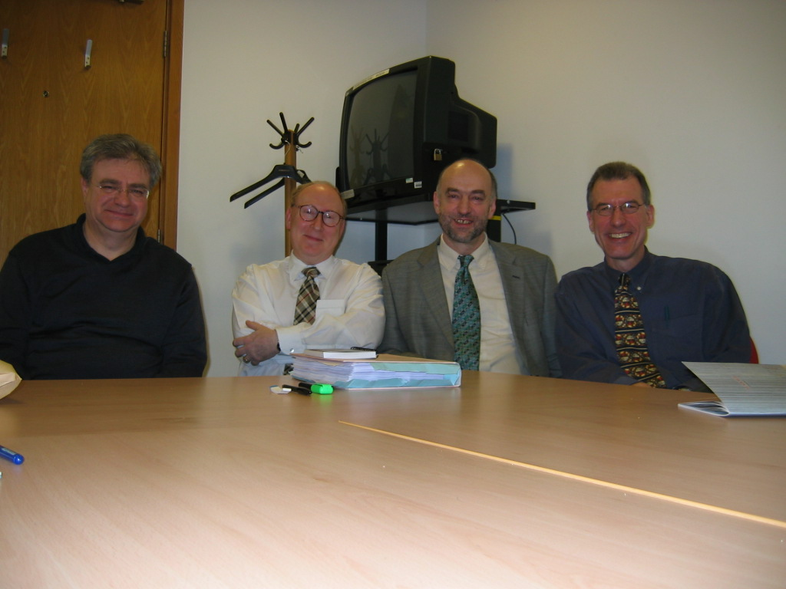

*Robin’s Ph.D. viva, London, 2005. Left to right: Michael Palmer, Philip Baker, Robin, Don Clarke*

But he was also committed to working with actual people and saved countless individuals.

Outside of the human rights field, he was a very talented guitarist and we had many happy hours playing together, some of which I managed to record and still have. He was great with his hands and loved to spend time restoring or improving guitars. As he once wrote to me,

I always say, I should have been a carpenter (or luthier) rather than an intellectual of any kind. I’m rarely happier than when I’m surrounded by my tools and doing some woodworking or fixer-upper project. In the new house, I have a great little eyrie-style workshop, with one side looking out onto a eucalyptus forest.

In 2014, he sent me an email saying,

I may need counselling: I'm on the brink of blowing a big wad of cash on a George Lowden guitar. (Specifically, a Lowden O-35 with cocobolo back and sides, and a redwood top -- about 4,000 Euro new.) I've twice played Lowdens and the experience was unforgettable -- incredible sustain and bell-like sonority. Just gorgeous!

Apparently he did not get the counselling, because the following year I got the following email from him:

I stopped off on the way home [from Germany] in Amsterdam for a couple of nights, so I could go visit what's probably the best guitar shop in Europe, The Fellowship of Acoustics (TFOA). It's in a little village about 90 minutes' train ride from Amsterdam, and they have a fantastic range of high-end instruments on show. I spent about five hours playing non-stop, and in the end placed a custom order for a Lowden, using a selection of exotic tonewoods that I've been lusting after for the past few years.

It's a Lowden O-50 guitar, made with African Blackwood (back and sides) and Adirondack Spruce (for the top). My custom model, which should be ready for delivery in about three months for now, will have the 45-degree armrest bevel option, as well as a 50-year old mahogany neck, and using flamed mahogany (instead of african blackwood and elm) for the binding, the rosette and the top headstock facing.

Price: 6,600 Euros! Sounds a lot, but if I'd ordered it direct from Lowden in Northern Ireland, with the various custom options I've chosen it would have cost about 9,000 Euros.

There’s a good lesson for all of us in how he ended the email:

And as the TFOA's company motto goes: “Life's too short to play a shitty guitar.”

As his friends know, you could not visit his house in Taiwan without getting treated to his magnificent sound system. It was one of Robin’s great pleasures to be constantly upgrading it with this or that. He once wrote me:

My latest hi-fi system tweak is going to be a Townshend Super Tweeter, which can easily output frequencies of up to 70 KHz, which approximates to what one actually hears (or rather: senses, since your ears don't go that high) with live music -- and the inclusion/transmission of which has the effect of clarifying the entire frequency range right down to the bass level (i.e. all the parts you *do* hear).

And he sent me this gentle bit of self-mockery:



Indeed, it’s because of Robin that I now listen to music mostly on vinyl and through a vacuum-tube amplifier. In addition to all this, Robin had not just an amazing knowledge of music, but what is to me an amazing ability to appreciate all kinds of music. “You’ve got to hear this!”, he would tell me excitedly before putting on a recording of some piece of modernist dissonance. I am afraid I must often have disappointed him.

One particular memory I will always treasure is visiting Robin and Pao-lien in their house in London around 2002 and reducing each other to helpless laughter as we read each other passages from a book about China written in a literary style that is best described as the full Foucault. The only other way that I can recall of making him laugh so hard was to voice Monty Python skits I had committed to memory.

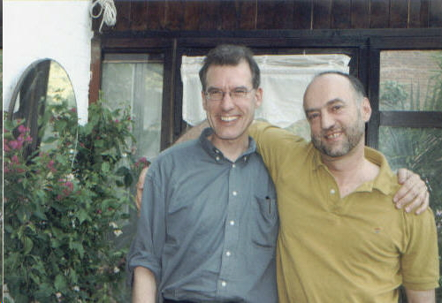

*Don and Robin, London, 2002*

Often someone’s passing makes us think about our own lives, and Robin’s passing is no exception. He is quite an inspiration to all of us to see what we can accomplish in the time we have been allotted on this earth. Robin’s was truly a life well lived. He did great things, and at the same time did not let his work consume him. After his cancer diagnosis, he very wisely chose to live a much lower-stress life—as he wrote me, “Just browsing [the [stewmac.com](https://www.stewmac.com/)] catalogue is an effective form of anti-stress therapy, I find”—and who could have been a better partner for him than Pao-lien? Whenever I saw him in Taiwan, his smile was always broad and relaxed. You could see he was truly happy.

In my high school Latin class, we learned a poem by Catullus that has always stayed with me. *Ave atque vale*, Robin.

Multās per gentēs et multa per aequora vectus  
adveniō hās miserās, frāter, ad īnferiās,  
ut tē postrēmō dōnārem mūnere mortis  
et mūtam nequīquam alloquerer cinerem  
quandōquidem fortūna mihi tētē abstulit ipsum  
heu miser indignē frāter adempte mihi  
nunc tamen intereā haec, prīscō quae mōre parentum  
trādita sunt tristī mūnere ad īnferiās,  
accipe frāternō multum mānantia flētū.  
Atque in perpetuum, frāter, avē atque valē.

Carried through many nations and over many seas,  
I arrive, brother, for these wretched funeral rites  
so that I might present you with the last tribute of death  
and speak in vain to silent ash,  
since Fortune has carried you, yourself, away from me.  
Alas, poor brother, unfairly taken away from me,  
now in the meantime, nevertheless, these things which in the ancient custom of ancestors  
are handed over as a sad tribute to the rites,  
receive, dripping much with brotherly weeping.  
And forever, brother, hail and farewell.



***Xiaoyang Clarke***

It is heart-wrenching to learn of Robin’s passing. Robin did fantastic work and had a significant impact on many people’s lives. What a great loss to the community! I heard a lot about Robin through Don for many years. However, I can never forget first meeting him almost 30 years ago. In the summer of 1992, I had just gone through a traumatic experience in Beijing, and Don arranged for us to meet. Because of his human rights work, Robin was the only person who really understood in detail what I had been through. His sympathetic questions and understanding moved me to tears.

Robin made me realize the fundamental rights and freedoms that belong to all of us, from birth until death. Robin has lived an entire life and contributed to humanity in ways we could all aspire to. Robin will be greatly missed.



***Sarah Cook***

I first met Robin myself when we both happened to be grad students at SOAS in London in the mid-2000s. In addition to his own cutting-edge research, he was brilliant, candid, and gracious in advice he gave me on a later visit to Taiwan. A conversation over dinner at his home with him and his wife ultimately inspired our 2017 Freedom House report on religious revival, repression, and resistance in China. I’m sure he was a mentor and adviser to many of us young China watchers and rights advocates, leaving his mark for years to come.

A sad loss.



***Geoffrey Crothall***

I was lucky enough to have known Robin for more than 30 years. At different times, in London, Hong Kong and Beijing, we were work colleagues, journalist and expert commentator, and, most importantly, just friends. Throughout, Robin was kind, generous and appreciative of my work. We had our disagreements – such as the week-long debate at China Labour Bulletin over whether to use an upper case or lower case P for “province” in a forthcoming research report – but the friendship survived.

I have many fond memories but the one that stands out – mainly because Robin would constantly remind me of it – is the time he came to Beijing in 1992 to debrief Han Dongfang after his release from prison, and prepare for his much-needed medical treatment in the United States. Robin stayed in my apartment in the Jianguomenwai diplomatic compound because he assumed it would be a relatively secure location for his interviews with Dongfang. Unfortunately, I neglected to tell him one day that I had agreed to let friends of mine shoot the interior scenes for a beer commercial in my apartment. They arrived in the morning, while I was in the office, set up their lights and cameras, and then left for lunch. Robin came back to find the front door open, lights and recording equipment everywhere. In a panic, he gathered up all his documents and rushed to the US embassy a few blocks away and left the documents there for safe keeping. In the end, no damage was done except to the beer bottles my friends had put in the freezer, which subsequently exploded.

On another occasion, Robin should have perhaps been more guarded. In 2006, he gave a talk at the School of Oriental and African Studies to the mark the publication of his book, *China’s Psychiatric Inquisition*. In the audience was the first political secretary at the Chinese embassy in London. Robin and I were going to dinner after the talk and the secretary asked if he could join us. Throughout the meal, he asked Robin a lot of very specific questions about his research and documentation, which Robin was happy to answer. It was only after he left that Robin had pause for thought. He turned to me and asked, “Do you think that guy was a spy?”

But my favourite Munro observation of all time is when he joined a few China Labour Bulletin staff for lunch one day at a tea house in Sheung Wan. Robin studied the exhaustive menu intently for a few minutes and was drawn to one item in particular, 法式多士 (Faatsi dosi in Cantonese). “What is this?” Robin asked, “Fascist toast?” For non-Chinese speakers, it was actually French toast.



***Meg Davis***

I first encountered him when I started working as China researcher at HRW in 2002. Robin had been out of the China researcher job for at least five years by then - I think he was actually the first HRW China researcher, if I'm not mistaken - but he left huge shoes to fill, given his extraordinary work in Hong Kong during and after the TAM protests and massacre, when he helped rights defenders get to safety, gathered and published research based on data they gathered, and authored the first groundbreaking reports for HRW. I didn't get to meet him in person until I'd been in the job at least a year, and had heard more than an earful by then about how amazing my predecessor was. So when we met for tea in Hong Kong, I was expecting a titan. Instead, he struck me as a kind, generous and gentle thinker, totally alive to all the postcolonial nuances and ironies of his/our jobs, careful, scholarly and thorough in his research, a staunch ally of Chinese rights advocates. His time on earth was not long enough, but he used it wisely and well and the world is a better place for having had him in it. 



***Jørgen Delman***

Robin was a true friend when we were students at PKU 1977-78 and our relationship continued for years. We met in London and Aarhus subsequently and last time in Hong Kong in 2004. Robin taught me to run, we biked and studied together, followed big-character campaigns at PKU and in Beijing in 1977-78, we sang and partied together, and we shared our passion for digging deep into China’s realities, even the harshest of them. I have the deepest respect for Robin’s work as a human rights scholar and for the work he did with Chinese dissidents. He stimulated my interest in China’s secret societies which I have followed since, taught about and recently made a podcast about (thinking again about Robin’s 1989 report on the issue when doing it).

At times, our relationship moved into our innermost feelings and emotions, and we shared the joys and sorrows there.

May he rest in peace. My warmest sympathies go to his wife and others close to him.



***Hualing Fu***

Like many of us, I read Robin's seminal work on political psychiatry before meeting him in person. He was then working with Dongfang on some collective bargaining projects with Chinese workers. It must be in the immediate aftermath of the Honda strike. I recall we co-organized some trainings and I got myself interested in labor dispute resolution and industrial action because of my involvement in some of the project activities.

Robin was a meticulous and forceful organizer - it was not easy to walk those activists from factory floors and NGO leaders through well-structured training sessions. The collective bargaining mock exercise that Robin led was in particular exciting, all those bargaining, trade-offs, and handshakes at the end were eye-opening, bringing an ideal type of labor relations, with great potentials in those days, to life.

We worked together on a number of projects, all related to labor relations in Guandong. Through the projects, I got to know some of the NGO leaders, and their lawyers, and some of their legal and industrial actions. Robin was a core member of the project team. I remember Robin was the person who introduced me to hushmail and reminded me firmly not to forward a message in hushmail to a non-hushmail address!

Robin maintained a high degree of idealism in working toward changing China and was at the same acutely aware of the practical constraints on the ground. He had a great sense of what was feasible as a project.

RIP, Robin. You will be missed.​



***Mary Gallagher***

I first met Robin in the mid-1990s as a graduate student based in Beijing, but traveling to Hong Kong to talk to people like Robin, Han Dongfang, Tim Pringle, Geoff Crothall and others involved in the human rights scene post-1989. I had a friend, Joyce Wan, who was working at Human Rights Watch with Robin and she must have introduced us. I remember him as a kind and serious person, who was always willing to help out students and people just starting out in the field as I was. He was unpretentious and unassuming, even though he was incredibly well-respected and admired. He will be sorely missed in the human rights community and by his many friends, including me. 



***Scott Greathead***

Robin Munro was my good friend and colleague who worked for my pro bono law client China Labour Bulletin for 18 years. I first came to know of Robin during the Tiananmen Square protests in 1989, when he was the Human Rights Watch representative in Beijing. As many have noted, Robin has saved many lives. One life Robin saved twice, the life of his great friend and comrade Han Dongfang, the workers’ rights advocate and founder of China Labour Bulletin. During Tiananmen, Robin became interested in meeting Han Dongfang, the young railway worker who helped organize the delegation of workers at Tiananmen known as the Beijing Workers’ Autonomous Federation, China’s first independent trade union. As one of the busiest foreigners reporting the events of Tiananmen to the world, Robin did not make it to the site of the workers’ delegation until June 3. Robin was among those who expected the military to invade the Square that night, and at their meeting Robin urged Dongfang to leave the Square before the military arrived. Dongfang was reluctant to do that, but followed Robin’s advice, left the Square and avoided the military’s massacre that night. Dongfang ultimately turned himself into the police after learning he was at the top of the government’s most wanted list. In 1992, after 22 months in prison, Dongfang was dying of tuberculosis. Robin came to Dongfang’s rescue a second time by leading an international campaign that pressured the Chinese government to release him to the U.S., where he was treated for his tuberculosis. As Robin later told a journalist about Dongfang’s commitment to workers’ rights and his willingness to face arrest, Dongfang “is just not prepared to back down . . . . [He] has just got integrity and determination.”

I came to know Robin personally in 2003 when Bob Bernstein, the founder of Human Rights Watch, asked for my help in getting Robin to Hong Kong so that he could help Dongfang with the important work of China Labour Bulletin. Robin was then in the UK, where he held a prestigious research fellowship at SOAS and was completing a groundbreaking work on psychiatric hospitals in China that was about to be published. But Robin’s commitment to human rights compelled him to leave the safety of Britain and join Dongfang in Hong Kong in the dangerous work of advocating workers’ rights in China.

Robin had long been a hero of mine for the lives he has saved and his brilliant reporting on China. But when he joined CLB he also became my *braw* friend who shared with me the stony beauty of our Scottish heritage, from Hamish Henderson and his *Elegies for the Dead in Cyrenaica* to Neal Ascherson's book *Stone Voices* to countless songs and poems. Robin embodied all that Robert Burns meant in *A Man's a Man for A' That*, and much more than that to me. I will miss him greatly.



***Peter Harris***

I knew Robin for more than forty years, and always admired him as a human rights advocate and as a person. His rigorous scholarship and unbending commitment to human rights were remarkable. I also liked him very much - clever, witty, humane, with a droll Scots sense of humour. We first met by chance in China in the bleak days of the 1970’s, then worked together at Amnesty International in London in 1987-1988, when his investigations into the systemic use of torture in China, drawing extensively on Chinese sources, showed what careful human rights research could achieve. After that our paths crossed now and then, over dinners on Cheung Chau island in Hong Kong, and lastly in Taipei in late 2011, where I spent a happy weekend with him and his partner, even though his cancer was already wearing him down. His views about China were well-informed, trenchant and intolerant of cant, and so were his thoughts on the world. Robin, you will be greatly missed.



***Hong Ying 虹影***

我还没有准备好，罗斌（Robin M）昨天下午走了的事实，虽然是远在美国的好友告诉我，我在脸书上找，有台湾朋友说到，他是不在这个世界上了。为了他所爱的一切，他从得病后，从香港搬到台湾淡水近十年时间，他和病抗争，读书听音乐，他收集黑胶唱片、养生练中国气功，身体如常！我都以为他顺利过了另一个世界的召唤，没想到今年四月时我和宝莲联系，得知他住进医院，是身体新地方有了问题。那时我有个不好的感觉，但坚信他这一次能挺过。我不敢打电话，怕又是她在医院里照顾他。但是没想到一个月，他就走了，早知这样，一定要打扰他，和他说话。他曾救了多少生命，做了多少了不起的事，他对一般的人，好朋友，都慷慨大方、正义、充满同情，失去他，对我们都是巨大的损失。瑟珀成长的过程中一直得到他的关爱，我们若在一个城市，不是见面，而是经常，也常约到一个国家旅行，好在他最后的岁月里，他们要么来意大利，要么我们去香港、台北，我们住在一起，吃在一起，谈论天地，如同家人，尤其是我在伦敦返回中国的那段时期。找了一些我给他拍的照片，很幸庆，我们五个人同游天桥立，住在同一家日本艺术家的酒店。看着你的照片，你是那么快乐睿智。在我生活的世界里，到处都是你的身影，亲爱的罗斌！你永远在我们的心里，爱你，永远不会改变！



***Sidney Jones***

I worked with Robin from Amnesty days in the mid-80s, through Tiananmen Square (before Asia Watch became the Asia division of Human Rights Watch), through the opening of HRW's Hong Kong office and the handover of HK to China. One side of Robin was the brilliant writer and analyst. He got access to information that no one else could dream of acquiring and produced reports (never to deadline, always in sudden spurts of hyperproductivity after long droughts) that were models of clarity and compassion. Robin broke every rule in the book to help people in danger. I don't know how many lives he saved, but it was more than a few. He would risk everything if he thought he could help. Sometimes we wanted to strangle him, and then we had to take it all back because he did so much and wrote so beautifully. Each of his reports was an adventure (trying to track products made by Chinese prison labour that made their way to the US at one point led us to look at the Minnesota Twins' "homer hankies" -- no evidence emerged of links to a laogai -- and at another to try and engage murder mystery writer Sara Paretsky, unsuccessfully, to look into a plant outside Chicago.) On top of everything, he was so entertaining and so much fun to be with, especially after a few beers, with tales of socialist Sunday school when he was little and his exploits as a Scottish bus driver. I can't even remember when I last saw Robin but he was still living on Lamma then, going for long walks and playing his Martin guitar. It seems like the distant past, when we were all so much younger and still believed we could change the world.



***Tom Kellogg***

Robin was so full of life that it’s hard to fully grasp that he’s gone. He was a man of many talents, and also a warm and caring friend who, along with his wife Pao-lien, was great company.

I got to know Robin at least a bit during the 1990s, when he was the Hong Kong-based China researcher for Human Rights Watch. I was fresh out of school, working for HRW in New York, and anxious to absorb everything I could about the practice of human rights research and activism, and also the situation in China itself.

Given that Robin was half a world away, I first learned from him through his writings on China, including the indispensable Detained in China and Tibet, and also various reports on human rights abuses in China. I was impressed by his scholarly rigor, and also by his commitment to taking on impossibly difficult subjects, such as the post-June 4, 1989 crackdown on protesters, academics, and activists. Robin’s work was required reading for younger would-be China hands like myself, who were both trying to wrap our heads around human rights in post-Tiananmen China, and also trying to understand how the research and reporting tools of human rights advocacy groups could be used to push Western governments to press their Chinese counterparts to end rights abuses.

As far as I can recall, we never met in-person during those early years: Robin never made it to New York during that time, and I didn’t make it to Hong Kong.

After I left HRW for law school, I continued to follow his work from a distance. As it happened, Robin himself departed HRW soon after I did, and headed to SOAS to take up a post as a senior research fellow. While there, he researched and wrote what I consider his most important scholarly contribution, China’s psychiatric inquisition: dissent, psychiatry, and the law in post-1949 China. A path-breaking work, the book – and other writings that preceded it – dramatically expanded our understanding of psychiatric abuse in China. (Indeed, Robin’s writings constituted the first major research works in English that allowed the world to even know that this problem existed.) Since its publication, China’s psychiatric inquisition has served as a key reference for countless Chinese and international scholars who have continued to investigate psychiatric abuses in China. I have also worked closely with Chinese lawyers who have done pioneering work on using the court system to free those who have been arbitrarily detained in mental institutions across China. They all openly acknowledge Robin’s vital contribution to our understanding of this cruel and under-studied phenomenon.

Our paths crossed once again in the late 2000s, when Robin was at China Labour Bulletin. I was traveling regularly to Hong Kong as part of my work for the Open Society Foundations, and I routinely met with Robin to get his take, both on the labor rights situation in China, and on human rights matters more generally. The work suited him: he was working for one of the top NGOs in Hong Kong, and was able to infuse CLB’s research reports and press statements with the same level of scholarly rigor and deep analytical insight that he had brought to his work at HRW years before. He was immersed in CLB’s work, was part of an amazing team that included his dear friend Han Dongfang and other top Chinese and expatriate activists and researchers, and was living in Hong Kong, a city he (mostly) loved. He seemed happy.

It was only after Robin left his full-time post at CLB that our friendship truly blossomed. I heard through the grapevine about Robin’s illness in 2011, and sought him out at his home outside Taipei soon thereafter to check in. He was recovering from cancer treatment, and yet he was still very much his old self: anxious to chat about China, and to swap stories about old friends in Hong Kong, London, New York, and beyond.

The fact that we were meeting outside the confines of work meant that our friendship also expanded and evolved in other directions. Though I had known Robin for several years by this point, it was only on that first visit to his home that I learned of his passion for music, and his serious addiction to high-quality sonic equipment. Both on that visit and on subsequent ones, we passed countless wonderful hours together, listening to records, sipping whiskey, and generally enjoying each other’s company.

It was also during that time that I got to know Robin’s wife Pao-lien, who somehow managed to keep Robin on his health regimen, which included taking various medicines on time, eating more healthy foods, and keeping the single malt consumption at reasonable levels. Their deep affection for each other was readily apparent; more than once, Robin remarked to me how lucky he was that he had found Pao-lien all those years ago.

In the years that followed, weekend visits to their home took on a loose routine: mornings would feature coffee and conversation, both about China and everything else that was capturing our interest. Then, a hike on the trails in the Yangmingshan National Park a short drive away, which whetted our appetite for dinner at one or another local restaurant. Then back to the turntable in the evenings, during which Robin would indulge my much narrower musical tastes (he was truly omnivorous, boasting a record collection that ran into the mid-hundreds at least). As the music filled Robin’s upper floor office and living room, we chatted away and Robin explained the many virtues of his truly world-class stereo system. Then to bed, only to do much the same the next day, before I would have to regretfully make my way back to Taipei.

As COVID put a stop to international travel last year, I fell out of touch with Robin and Pao-lien – I waited for normal life to resume, and for my next visit to Taipei to get on the calendar, after which time I would shoot Robin a note and we would arrange to meet. News of his untimely death took me completely by surprise – I had just assumed, as perhaps many of his friends did, that someone as vitally alive as Robin couldn’t be taken from the world. But of course he could, and he was, and we are all left to mourn the loss of a prolific scholar and a dear friend.



***Barry King***

I am one of Robin's newer friends, having known him for 3 or 4 years only. But we bonded immediately, both having interests in music, DIY home improvement, and bringing old things back to life. I found a 1963 Tesco electric guitar in a second-hand shop that Robin took passion in and taught me how to properly restore. He helped me re-build a back deck at my house, and I introduced him to biking the scenic mountainous roads around where we live. Biking seemed to open a whole new passion for him, and Robin would often go out on his own if he couldn't find friends to ride with—even to the point of competing with himself on a timing App on his phone. One self-described “Crash-Boom-Wallop” while biking alone nearly took him from us earlier, but he recovered quickly (big thanks to Baolian) and jumped right back on the saddle.

I was really looking forward to having him as a nearly next-door neighbor for many years. At least Baolian is still there and Robin's presence is felt. He will be missed.



***Dinah Lee Küng***

Thanks for letting some of us weigh in, even if it is only a few happy memories of Pao-lien and Robin. While I was bureau chief for Business Week in HK, Robin and I discovered through Scott Bellard at the US Consulate that we were both working on prison labor from very separate angles. So Robin and I decided to pool our resources and research and we agreed to time our releases for the same day for both the BusinessWeek Int. feature and his Human Rights Watch report. Frankly, that's not someday any journalist risks doing with someone they don't know well as a rule, but Robin was the kind of professional and gentleman one could trust not to jump the gun.

Similarly, my husband Peter, then the East Asian delegate for the Int. Red Cross covering China, Tibet, Taiwan, and the Koreas learned Robin was gathering names for a directory of detainees. Peter came pretty close to breaking the ICRC rules by supplying an updated list of Tibetan prisoners gathered by Tibetan Red Cross workers and smuggled out to HK. To do that, Peter had to trust that Robin was not going to betray his sources of the Tibetan names as linked to the Red Cross.

Amusingly, Robin could be a little too pre-occupied with his work. When my husband Peter and I were leaving Hongkong for good in 1992, we scheduled a smallish good-bye dinner with close friends at our apartment at Branksome Towers. The night before, the doorbell rang and Robin and Pao-lien were there on the doorstep beaming hello, but one day early. It was pretty obvious that Robin had scrambled his dates. So, inadvertently, we had them as guests for two nights in a row instead of one—and how lucky we were.



***Nancy Li***

With his razor-sharp intellect, grotesque encyclopaedic knowledge and memory, multilevel-penetrating analysis, his eloquent précision, his 4th-dimension humour that often does not make you laugh right away but makes you laugh all the time for the rest of your life, his ever simmering anger – just this side of explosion - for justice, Robin sweeps you off on a crazy-ass mission, things that you would not do for anybody else, When you are in the eye of Typhoon Robin, you are living the most febrile moment of your life. You live on no food, no sleep, just your common conviction and the fuel of his charismatic passion. How not to mention the pale fire warming Robin all these years? Paolien, her uncanny spiritual perspective, her silence and that quality of silence, her striking looks, her limitless kindness and patience, she has given the 空間 that allows Robin to be fully the Robin that he is, that we love. Once I heard Jim Wong 黃霑 say in a talk show: “Men don’t want women to give them complete freedom, but the illusion of freedom. We men are all big monkeys. We want to be tied to a woman on a long leash, at the end of which he could move and jump and agitate, yet he is on a leash.” Jim might as well be talking about, well, about so many, especially Robin. Robin, I have no words to say how much I miss you, how you took so much of me with you. You liked to say about our work together: “We had a good run.” Robin, you had a fabulous good run.

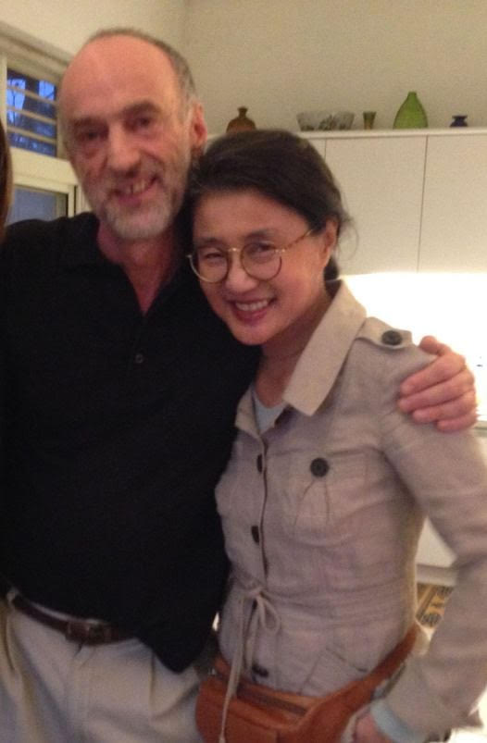

***Jutta Lietsch***

I first met Robin in 1979 as a student at Nanjing University. He was fun and serious at the same time, had a wonderful scottish lilt, and the walls in his dorm room were full of calligraphy that he and his roommates did on the side.

Later on we met again once in a while, when Robin worked with Amnesty International und then with China Labour Bulletin and I was a correspondent in China. Whenever we journalists called to ask about his work, or to have some new development explained - be it about black jails or disappearances, new repressive regulations or labour issues - he patiently took the time to explain what was happening. I remember how he would answer calmly and precisely - never exaggerating, never generalizing where it was not warranted, but pointing us to look at things that we had not considered before.

To have someone like Robin to talk to is very precious. How sad to lose him.



***Liu Xiaodi 劉曉笛***

宝莲

黄女士芳鉴：

悼罗斌

平生有奇志，公推当代英雄汉；

盖棺不论定，我拾芳草赋招魂。

惊闻罗斌先生仙逝，拭泪痛悼！我们曾经是朋友，那时，我固执的相信彼此是能够以身家性命相托付的至交。上帝掷骰子，我们被纳入两条平行的轨道。但是，先生生命的谢幕，我有痛彻心扉的哀伤。因为，这将预示着我们共同坚守的时代正在远去……

在此谨嘱宝莲女士节哀顺便。江湖秋水，所翼无他，惟愿珍重珍重！您题签的那册《流氓治国》，我藏珍专匣。一九九四年耶诞日，先生惠赐贺卡。其时，我避秦蛰居，孑然一身，囊中羞涩，四壁萧然，无以桃李之报。特意执管手书旧作《问春长歌》一阙回赠罗大侠，今再录附后，以资纪念：

小園春

東風隨

閒倚危欄

儂把東風怨幾回

怨且怨

不怨東風又怨誰

殘陽明滅

浩浩思

茫茫感

綠醉紅軟

淡淡愁

頻頻罍

柳煙花霧

最是傷心處

塵影空尋

舊夢已昨非

春歸

春歸

春歸又嫁桃李梅

每逼暮

至唏噓

灞陵上

柳絲長

繫不住一抹斜暉

臨高臺

賦焚稿

怨東風

不思量

東風怨儂意頹頹

怎女郎

嬌嗔嗔

羞答答

怯生生

膽氣銷磨

悶懨懨

閒慽慽

懶慵慵

總蹙黛眉

不忍聼

瑟瑟風

簌簌雨

憐蕊寒香冷

還須度

韋孃曲

引得那

蠭兒舞

蝶兒飛

辨俠骨

說荊軻

望停雲

發浩歌

俯天仰地

丈夫立身

狂劍怨簫

書生本末

早看天

待雞鳴

彈鐡鋏

酹新醅

上紅樓再問春消息

正東瀛蹈浪

風揚髙桅

右《問春長歌》一闕，此係甲子元夕夜，為和先父明堂賀嵗之作，偶吟於開通巷舊宅揖水拜石齋。時蟄居困頓，獨處岑寂，室若漏甑 ，四顧蕭然，唯半壁書冊殘卷相擁。燈盞微茫下，冷酒孤傷，自斟自酌，頗擊節先路棘莽，風雨旦夕。思經年備受流言詆丑，病詬猥辣。又迭因書生立身，擇善固執，特立獨行。師法自由之思想，獨立之精神，不屑傍人門戶而尤嗜求異端，訪禁書，讀百家語。或沉潛磨濯於新學，以砥礪品行操守，涵養吾之浩然之氣。或為生命尊嚴計，而遍搜赤纛圖騰普儸鐮錘北斗星紅太陽其所經略之冤抑戕害殘斫刑戮塗炭生靈舊案之未聞之聞。寒暑寤寐，不敢一日弛怠。曾撰室聯曰：「 海水正橫飛，誰欲驚瀾試一搏，天風洗塵衣，我拾芳草賦招魂 」自正其心。自勉其志，自壯其氣，玆有鄉賢少默先生握管親以古隷法書之授我，用心大要在於鼓勵後來者。陋巷布衣，憂樂天下，功魁罪首，抑濁揚清。扞格時政，必追本逐源，鏡考得失，名實聚訟，訝詰所由，且皂黑絲白，魏紫姚黃，尺長寸短，槼圓矩方，沈病潘愁，燕瘦環肥，鸡鸣狗盗，文张武驰，顺姑失嫂，天地人，儒释道，法术势，尧禅禹让，桀暴纣虐，殷损周益，秦法汉随，孔仁墨義，孟善荀惡，韩苛管酷，卯逆跖盗，咱家自有權重計較，並不以廟堂之是非為是非。亦牴牾衣冠之士仰承風旨，抱道心腸，幫閒嘴臉，天衡校一而定准的，毫釐失範，即匍匐車塵諛乞權柄懸置厲禁。相向形骸放浪骨骾狷介者，則訛指離經叛道，直以寇仇應對之。攻訐訾謾，鴉聒蟬噪，語多病狂無稽，其行狀之卑瑣疑甚於扒祖墳揭老底斷糧道也。凡涉口角交惡，輒言主義公理大同顛撲不破真理之祖宗家法，問敢有誰斗膽越此雷池哉，令道隅側目而不知恥，自不知此乃國之宿恥也。究其門墻冊籍，無非曲學阿世之途轍一路，偏精王霸道者諱，深諳神器壺中玄奧而已。至可切齒鄙恨者，鷹犬環伺，晝夜警惕。魍魅姻婭，朋比爲奸。彼等狐鼠出沒，僕臣行走，左不過李斯貝裏亞輩嫡傳香火。竊自喻磚石器具齒輪螺絲釘，唯知俯首犬馬，為王先驅，效死擅專之政。雖肖小然以機謀詭詐論，智計殊絕君子不知凡幾。其身手之陰騭老辣，盡在設密匭，結網罟，佈陷阱，構羅織，操縱衣食，堤防思想，馴馭舌辯，鉗錮口鋒，壟斷傳媒，羈絆輿論，鼓掌民意，玩弄刑名，緣坐無辜，離間手足，折辱士子，潰畔師門，墮節歧見，誣控強項，臠制眾聚，鞠訊黨人，牢籠但開風氣之先者，虐殺黃道河、彭令昭人傑鬼雄拼凝血與山川共碧之一脈正氣。有集東厰閹黨之百毒于一身，莫此爲甚。槌杵枷鈕，斧鉞鋒鏑，鬼蜮伎倆，鉄血手段，無所不用其極，無所不窺見其用恶之心，酷苛倍於虎狼秦。如此肝肺，屢譏余一市井屠沽村野耕氓販夫走卒升斗小民引車賣漿者流，不在其位，敢以鄭聲亂雅樂，心達而險，諸惡之冠，罔有攸赦。自此謗毀及身，橫離踵其後，幾被鼎鑊之劫。每至暗夜叩問，阮籍失路，涕泗滂沱，指天劃地，卻不知何處歸宿，頓覺愴然痛切，為苦而莫可名狀，陡生喟嘆矣，遂乃拍案發錐心之悲鳴。逾宿，塗鴉私韻長歌，籍此以勾勒懷抱也。近遇暇，復誦再三，略潤色。

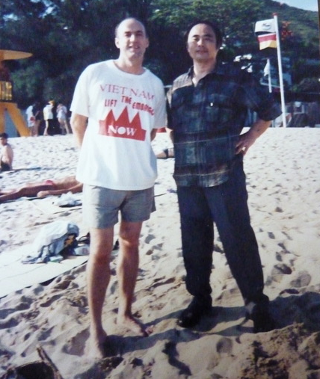

*双峰并峙，谁不期待拥抱和携手*。

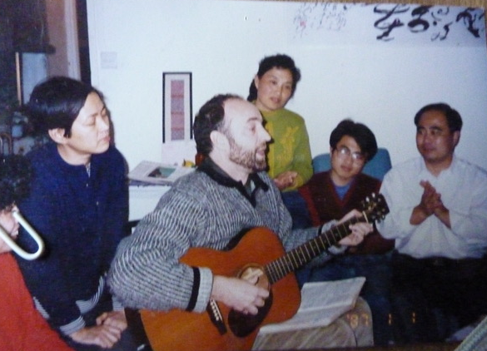

*温馨时刻，令人怀念的日子*



***Francis Moriarty***

A truly great guy, an amazing linguist, serious scholar, lover of music and terrific lunch companion. Oh, and a serious audiophile. RIP



***Chinese classmates from Nanjing University, 1978-79***

*给罗斌妻子悼词*

惊闻罗宾辞世噩耗，心痛不已。

中国大陆高考恢复仅半年，我们因缘际会，共同居住在1幢三层楼中，那是南京大学鼓楼老校园中的九舍。

文化碰撞让我们打开眼界生诸多涟漪，朝夕相处各肤色欢声笑语添人生趣忆。  
罗宾出色的勤奋好学与涵养礼貌，给我们留下了深刻的印象。

一朝握别，从此天涯。

有星星点点的消息传来。数年前知道罗宾病了，我们相信且祈祷他坚强的毅力与先进的医疗，特别是贤惠美丽妻子的陪伴照护，美丽宝岛台湾的环境滋养，诸多加持可使病魔怯退。

然上天爱才好德，过早过急的收回了罗宾，人间少了一位绅士，上天多了一位使者。

我们祈愿罗宾在天堂重生，在云朵中，在星光中……继续深爱着地球人类和他的亲朋好友。

罗宾安息！

亲人安心！

当年九舍部分陪住生：

管永星  
徐大同  
赵力华  
张彩娟  
许忆先  
李晓晖  
海蔚蓝



***William Nee***

The human rights movement lost a true legend. Robin Munro was a meticulous researcher: a stickler about facts and the truth. His bombshell research reports reflected his degree of detail.

He also cared deeply about humans (and their messy, often complicated situations). His charisma and passionate care about individual human rights cases made his advocacy effective, and helped save countless lives.

It was really one of the great honors of my life to start working at China Labour Bulletin in 2008, and have the chance to work closely with Robin for two years.

He was a great mentor, and most importantly, he was really a great friend to me and so many others. When working with him, a quick question about some mundane aspect of a report would often lead into a three-hour meandering conversation about China in the 1980's, political trends in the US, harrowing and unpublished accounts at saving dissidents clandestinely in the 90s, famous novels, the finer points of classical music and many other topics. He had the best stories and a wonderful sense of humor.

He will be sorely missed.



***Malin Oud***

I first met Robin twenty years ago when I was studying Chinese law and human rights at SOAS in 1999. Robin was a research fellow at SOAS and gave a lecture on Chinese criminal law to our class. He was hugely knowledgeable and impressive, but also unassuming and kind. Robin invited me over for dinner at his and Paolien’s house in London, and we became friends. We stayed in touch over the years and crossed paths at different points in Hong Kong, Beijing and Stockholm. I tagged along with Robin to the National Library in Beijing when he was going through Chinese psychiatric journals for his groundbreaking research on psychiatric detention. Robin stopped by Stockholm on his way to Oslo to attend the Liu Xiaobo Nobel Peace Prize ceremony in 2010.

Conversations with Robin were always engaging - serious but also a lot of fun. Robin had a wry sense of humor and enjoyed my complaining about Swedish smugness. I was so very proud and honored when Robin invited me to join the Friends of China Labour Bulletin board two years ago. My last conversation with Robin in March revolved around the Hong Kong National Security Law, but also around Swedish herring and schnapps. Robin, I clink a glass of cold Swedish akvavit against yours. I will miss you greatly.



***Michael Palmer***

*PhD supervisor for Robin at SOAS, whose 2005 doctoral dissertation was published under the title: China's Psychiatric Inquisition: Dissent, Psychiatry and the Law in Post-1949 China (London: Wildy, Simmonds & Hill, 2006).*

I deeply mourn the loss of Robin, and greatly admire his work in the struggle for human rights development in China. Robin was a perceptive and committed human rights scholar and practitioner, and kept in good spirits despite a long struggle with illness.



***Matthew P. Robertson***

It has taken me a couple of weeks to process Robin's death. I recently read some emails from him and was heartbroken. Robin has been a central inspiration for me for the last eight years. He's actually half-responsible for my current research focus and life trajectory—it was a day we and our wives spent together in 2016 that led me to eventually enroll in a PhD programme and attempt to do what he would have done, if he had the opportunity, on the issue of organ harvesting in China. In fact, I consciously titled my [2019 Victims of Communism Memorial Foundation report](https://perma.cc/27YC-6X8T) after his own 1994 report for Human Rights Watch, “[Organ Procurement and Judicial Execution in China](https://perma.cc/QE5S-WPM2)” (changing ‘judicial’ to ‘extrajudicial’, per its focus).

I had known about Robin's work on psychiatric abuses for a long time, and carefully read nearly all of it. The only work of his on the subject I hadn't got to was his dissertation-cum-doorstop, “[Psychiatric Inquisition](https://perma.cc/3TBH-LGZE).” The copy I have on my bookshelf now came with me from his rambling home on the outskirts of Taipei first to New York, and now Canberra.

When I emailed him while in Taipei, he responded the same day, and we arranged to visit the following day. We had lunch and dinner, listened to records together on his sound system, and in between spoke about everything. Despite his flagging health, I counted six hours of intense conversation, much of it about the human rights game and organ harvesting. I was fascinated by his range of knowledge and interests, his humor, and his humanism. Incredibly, he even made a passing reference to so obscure a figure as the Armenian mystic Gurdjieff! Truly a first for me in such company.

Before I took up the task of studying China's organ transplantation system as a full-time occupation, I bought and downloaded everything of Robin's I could find. I was, and remain, completely impressed and humbled. It is clear that when reading his words one is encountering his mind. His writing is clear and sharp. His moral commitment to his subject never gets in the way of the raw evidence he marshals, or the careful inferences he draws from that evidence. I will never do what he could and should have done on the topic of organ harvesting, but his example will remain an ideal for me to emulate.



***Scott Savitt***

*獨一無二 dúyīwú'èr {E} f.e. ①unique ②unparalleled*

One of my biggest regrets about being imprisoned/deported was seeing less of Robin and Pao-lien. I only saw them twice post-2000. but during the previous two decades I spent as much time as possible with them. Robin and I played as much guitar together as talked politics. Many of his China colleagues don't know that Robin was a professional-level fingerstyle guitar player and singer. He loved this joke: Human Rights Watch sent me to Hunan on assignment, and a local official said to me regarding 江澤民：“這光是主席個人的意見!” [for those who can't read Chinese: a local official said to me regarding Jiang Zemin: “That's just the Chairman's personal opinion!” — illustrating 上有政策, 下有對策/central leaders have policies, local officials have counter-policies. Robin couldn't relate this story without bursting into a belly laugh, complete with a convincing Hunan accent. I already miss my 蘇克蘭大哥/Scottish big brother.

Another Robin memory from an exchange with a close friend of Robin's/his wife's:

Friend: Everyone talks about his encyclopaedic knowledge of human rights. What about his encyclopaedic knowledge of old revolution (or Cultural Revolution-era) slogans and songs? Dissidents who had just escaped would stare at him with their jaws dropped.

Me: Re: dissidents' jaws dropping, the problem is that can happen when white people use chopsticks. Robin next to e.g. Perry Link or Geremie Barmé wasn't extraordinary. Us 老外 lifers exist in the same milieu, there are quite a few of us out here. What Robin was 獨一無二/unparalleled at was applying his encyclopedic/diverse/esoteric knowledge to helping flesh-and-blood human beings. You know he and Han Dongfang set up China Labour Bulletin from scratch? How many ivory tower scholars do that?! Another funny story: watching Robin write those Human Rights Watch reports [let's call them what they were: meticulously-researched books] in their pied-à-terre on Lamma Island 1989-1998, I once remarked: “Dude, why don't you have a Ph.D., you're the foremost expert in the world on this subject?!” He took a rare break from his work, got pensive, then said: “You're probably right, Scotty, I need a credential to be taken seriously.” It was after that he returned to SOAS to finish his terminal academic degree. He'd been working on the front lines/in the field so long, and felt that there was so much critical work left to be done, that he never put career promotion first. In this sense Robin was 獨一無二.



***Betsy Shieh***

I only met Robin a few years ago but quickly fell in love with him and Pao-lien. Robin's battle with his illness, his approach to life, and his dedication to his work, his music, and the love of his life were an inspiration to Shawn and me. When Robin told us he wanted to get Pao-lien situated in her dream house knowing he would pass before her, we bought their home in Taipei in the hopes that a bit of their lives and loves would rub off on us. It is not surprising that whatever was brewing in Robin's body waited until he could get through the transition. We will feel Robin around us every day and he will continue to inspire.

Sending love and condolences.



***Shawn Shieh***

I haven't known Robin as long as some people but I got to know him well over the last few years. Robin left China Labour Bulletin rather suddenly in the early 2010s after he was diagnosed with cancer, and I was invited by Han Dongfang to join CLB as its Deputy Director to fill Robin's very large shoes. In my work at CLB, I found myself helping to carry out the groundbreaking but very low profile work that Dongfang, Robin and others had started on labor organizing and collective bargaining with our partners in China. Ironically, I got to know Robin even better after leaving CLB in early 2018. My wife and I traveled to Taiwan several times and we stayed at Robin and Pao-lien's house and came to love them and their home. In October 2019, we went on a road trip with Robin and Pao-lien to Taiwan's stunning east coast. We arrived at our bed and breakfast south of Hualien just as a typhoon was making its way up the coast. We woke up the next morning to a clear windy day and went up to the rocks on the beach where I took this picture of Robin at peace with himself.

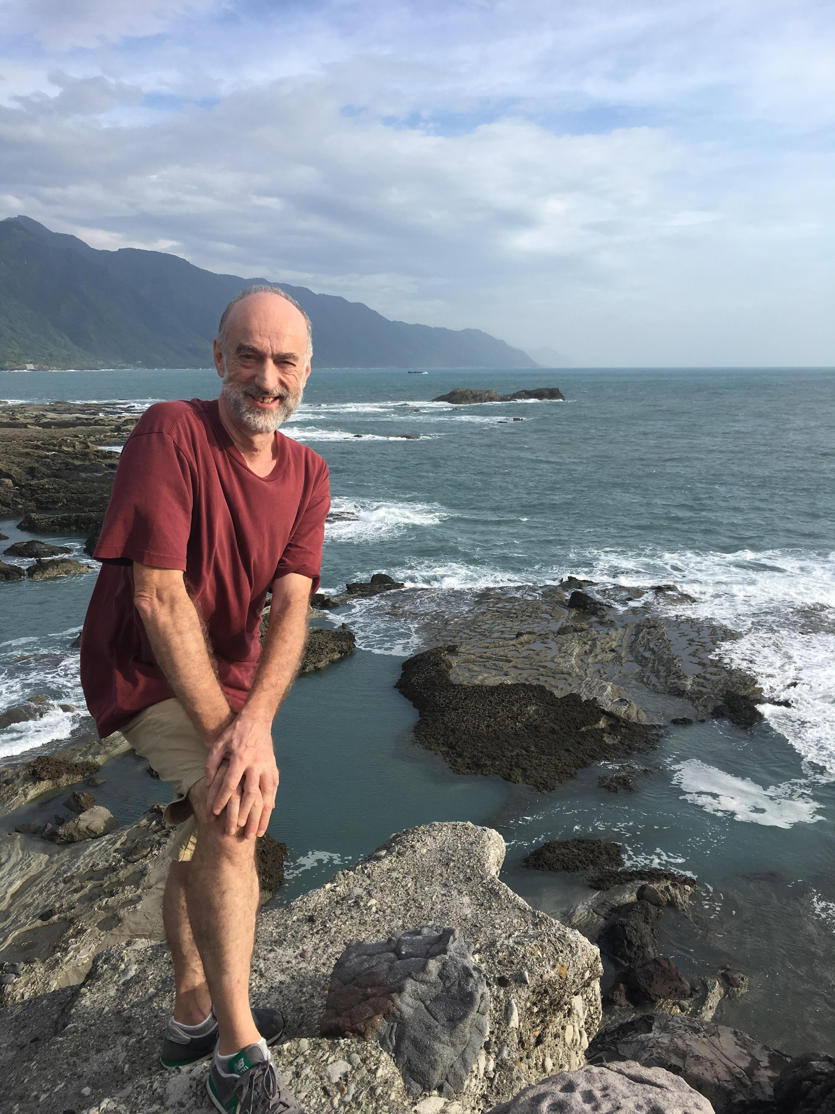

The year after, Robin and Pao-lien were looking to downsize and move into a smaller home nearby with a bigger yard. Robin wasn't sure how many years he had left and wanted Pao-lien to be comfortable and happy doing the gardening that she loved. They asked us if we wanted to buy their place and we gladly took them up on their offer. Not only did we love their house as a place to retire, but we thought we'd be neighbors. We talked about taking long bike rides with Robin, going to the hot springs and taking walks in Yangmingshan national park just behind our home.

The last time I saw Robin was in January of this year when I took a trip to Taipei to take care of our new home. Robin and Pao-lien generously stocked the fridge with food for my two-week quarantine and Robin spent hours driving me in his Jeep to the bank, tax office, and stores. The more time you spent with Robin, the more you realized what a decent, generous and open human being he was. He cared about you more than he cared about himself and he made you feel that he was your best friend. We talked during that time about how his health had improved, despite some scary bike accidents, and how he seemed to have beat the cancer. He knew that the doctors had originally only given him months to live, and he had cheated death by extending those months to years and years. We looked forward to the time we would have as neighbors and all the things we would do together.

The news of his death came as such a shock because my memory of him so alive and well was so fresh in my mind.

In their old house, the top floor is my favorite. It's one large room with a view of the Taiwan Straits. It was Robin's man cave where he put all his audio equipment, records, CDs and reel-to-reel tapes. It was where we spent hours listening to Cat Stevens and Verdi operas and everything in between. I'm truly grateful that we bought the house from them because I can't think of any more fitting memorial to the man and his generosity of spirit than to stand in that room looking out to the sea and listening to music that we loved.



***Francesco Sisci***

To me a book he edited and translated in1986 was very important, and very relevant today “China: Crossroads Socialism” a manifesto for a proletariat democracy by Chen Erjin.

It detailed to me for the first time that during the Cultural Revolution many young people supported Mao believing that he would push for freedom and democracy. This has been a constant undercurrent, as Robin Munro pointed, in the CCP. As now the former young Red Guards are in power this might be important again. As young men they wanted freedom, liberty, democracy in a confused and confusing drive.

I do believe this drive still exists and still has some appeal in the mind of Chinese Officials. Munro’s calm and cold manner to push for human rights and freedom of some people, as Donald Clarke noted, perhaps could work also because it presented rational arguments for human rights that his counterparts had to take seriously possibly because the issue of individual freedom was real and gnawing at them and at the system.

Sidney Rittenberg also wrote beautifully about this drive during the Cultural Revolution: he thought really that Mao was going to push for some kind of democracy and freedom. The fact that the Party betrayed them and their hopes doesn’t mean that that flame is extinguished within the party.

We are at terrible Crossroads again and he is just too sad that he passed away now.



***Harold Tanner***

I first met Robin in London, fall of 1984 or spring 1985, when I was in the MA program at SOAS. Our paths crossed again in, I think, 1991-92, when I was doing Ph.D. research at the Universities Service Centre in Hong Kong. Robin invited me, my wife and our one-year-old daughter Sophia over to Lamma Island one day. On the boat ride over to Lamma, Robin made hilarious faces and noises, successfully keeping Sophia entertained throughout the boat ride. The day passed so pleasantly—hanging out, swimming, dinner. Han Dongfang, recently out of prison and carrying around a large plastic bag of TB medication, was there. We wound up spending the night, sleeping on quilts on Robin & Pao-lien's apartment floor. Dim-sum breakfast at a sidewalk restaurant down in the village the next morning—and Robin suddenly appeared, having missed his ferry to work that morning! Robin also asked me to do a bit of research for him, looking for material on psychiatric abuse of political prisoners. I found some material for him—not sure how useful it was. I wasn't satisfied with it myself, but he kindly said that it was very helpful, thanked me, and paid me for my efforts. And then, of course, I finished my Ph.D., got a job in Texas, and life changed—from international travel, and crossing paths with the likes of Robin, Liu Xiaobo, Chen Kaige, and Perry Link, to a rather isolated provincial life in the American heartland. But, like an echo across the decades, the treasured memory of the kindness and hospitality of Robin and Pao-lien, the simple pleasures of a swim, a good meal, and pleasant company on a small island on the other side of the world.



***Laurence Vandewalle***

Robin was a beautiful soul, committed to make the world a better place. He personally did a lot to help whom he could. He has deeply changed my apprehension of human rights in China when he spoke in a conference I was organising in the European Parliament in the late 90’s, and when I was in Hong Kong – I keep fond memories of long discussions on China, on human rights, on labour rights, June 4th … in his charming house, with his wife too. I am very grateful.



***Wang Lingling 王玲玲***

得知罗宾芒罗先生去世的消息，深感遗憾、惋惜痛心。虽然不曾谋面，但得知他是一个值得敬仰的国际人士。做为一个外国人，他能够关心体恤平民百姓的疾苦，为政治受迫害者实地调察发声，声张正义。他值得人民永远怀念他。罗宾永远活在我们的心里。

Hearing the news of Mr. Robin Munro's passing, I feel deeply sorry and sad. Although I have never met him before, I learned that he was an international figure worthy of admiration. As a foreigner, he cared for ordinary people's suffering, stood up for political dissents, and fought for justice. He will be missed by the people forever. He will always live in our hearts.



***Clare A.P. Willsdon***

Robin was one of my “Scottish cousins”, the son of my mother Dorothy’s older sister Ailie. Living far away in England and then Wales, I didn’t have much opportunity as a child to get to know him, and as adults our paths diverged still further, though my late parents were truly delighted to meet him again at Ailie’s funeral. I sadly couldn’t attend myself on that occasion, but I remember them speaking most warmly of his generous welcome.

However, when my mother died in 2017, after my father in 2014, the magic of email enabled me to contact Robin, and we had the most wonderful exchange in writing. Whilst I knew of his brave and principled work for human rights, here was someone who also had time for a far-away relative. He recalled having been with his own mother as she approached death, and how “the long vigil felt like one was holding faith, somehow, and the moment of death was like bearing witness to a deep mystery”. That description resonated so perfectly with what I had just experienced, that I could hardly believe it when he went on to say that he’d recently bought a set of LPs of Kathleen Ferrier singing Bach’s St. Matthew Passion, and himself loved her biography that I’d been reading to my mother—a great Ferrier fan—in her last days.

He wrote so perceptively of what Ferrier’s singing must have meant to my mother’s generation in the post-war period, that, through music and the memories of it, the space that separated us seemed as nothing; it was though he had reached out a strong hand to support me in my loss. Reading more, as I then did, about his extraordinary achievements, I realised I had been privileged to experience the empathy and insight that must have been so critical also in his human rights work. Alongside reflecting on that “mystery” of death, and the power of music, he was warm and funny, sharing my enthusiasm for gardening, and recalling his childhood affection for Glasgow, where I now live; a city he mischievously contrasted with its “glum counterpart, Auld Reekie” (Edinburgh). He spoke of hoping to visit Glasgow again one day and generously invited me to visit him and Paolien in Taiwan. It’s a tremendous regret to me that none of that can now be, and, as well as adding my voice to the many tributes to his public achievements, I would like to record the debt I personally owe him: thank you, Robin, for your understanding and encouragement at that difficult time in my own life. I hope this recollection may in turn comfort others, especially Paolien and Sandra, who mourn his passing.



***Xu Datong 徐大同***

Hello, old boy! 這是我兩在南京大學時的互稱，當然是你教的。

當年你教我欣賞The Beatles, Bob Dylan, …… 我讓你體會中國書法，你的一幅草書唐詩作品被學校送刊於大陸《書法》雜志（見下圖）。

有人説我1989年後在思想上變化很大，我告訴他們，再往前推十年，79年時，我已在南京大學同學室友那裏閲讀西單民主墻資料了。

難忘1989年6月4日白天，我兩在天安門廣場邊不期而遇，一同蹲在花圃躲避坦克射出的子彈，……

老來常懷舊，懷舊總思友。不久，6月1日是你的生日，happy birthday to you!

Miss you, old boy!



***Rainbow Yang***

Robin is a courageous man who gives his life for other, especially for Chinese people. He is our hero.

As a British scholar, Robin could have an easy, successful career, a safe and comfortable life, yet he lived in Hong Kong, a sensitive and dangerous place, for the freedom of Chinese people. He presented his love, kindness, generosity, wisdom, humor and knowledge. His courage amazed all who knows him, including the Chinese government officers. I remember when I was visiting Robin in Hong Kong, he told me in smile that Chinese secret agents may come to knock his door at any minute. I remember he reassured me in an extreme hard situation: “It is so difficult. But I will not give up.”

Another interesting thing is Robin Munro and John Kamm’s “good dog, bad dog” team. Together, they saved thousands of Chinese people’s lives—from active political prisoners, to innocent civilians; from adults to children. Together they turned tear to joy, separation to reunion, desperation to hope, and death to life. Together they bring light and strength to people in the darkness.

Please join me to give thanks to Robin, the man who lives incarnationally and gives his life for the freedom of Chinese people. We thank him for inspiring us to continue living in love, faith, and courage. He will be remembered and loved forever!



***Yueyue Wenren***

—For Paolien & Robin and all other friends nearby and far away

煙火嘉年

--悅閱

希望上昇時如同煙花

劃亮夜空下

心中的角落

你我只有一瞬的年華

彼此打量

他眼角仿佛有點光影

折射出世間旖旎

我們已經到達山頂

煙花上升

綻放的位置比我們還高

然後墜入山谷

下山的路極其沉寂也無燈照

叢林在我們身畔蔓延

延伸處又見燈火綿連

我們已經下山

回到人間

我們與人群擦肩

聽到下一場煙火的預言

然後回首仰望

尋找曾經站立的山巔

也許將別無選擇

在那樣的時刻

再次上山

看煙花上昇冉冉如歌

此刻人潮洶湧如浪席捲

然後潮退好像流川

寂靜後 我們在原地

還在人間

*Our Moment of Fireworks*

(Translated by GiGi Chen)

When hope rises it does so like fireworks

under the light-painted night sky

and in the corners of our illuminated hearts

we have but an ephemeral stroke of time to stand—high

and take each other in—

the corners of his eyes spark with light and mystique

reflecting the brilliance of the world therein—

we have already reached the peak

The fireworks rise

and burst higher than even us

then cascade into the valleys below—

the road down the mountain is exceedingly quiet and without lamps’ glow

the jungle sprawls out beside us

but extending out of the endless dark we again see the unbroken line of lights—

we are already down from the hills

returning to where our world lies

We meet and brush past the crowd

hearing murmurs of the next fireworks round

then turn and look up

seeking the once-standing mountain cusp—

perhaps there will be no choice

when the moment comes

but to go uphill yet again in rejoice

to watch the swell and rise of the fireworks’ melodies

The sea of people now rages with the turbulent sweep of ocean waves

then ebbs with the flow of fleeing rivers

after the silence we still stand in place—

still in this realm’s space

